ID2209 – Distributed Artificial Intelligence and Intelligent Agents

Final Project

Group 38
Mert Alp Taytak
24 December 2019

Introduction
In this project we were given the task to come up with something that would require all of the skills we have learned over the course. After much thought I decided to design a model of a harvest festival. I had imagined more of a medieval theme; however, it is hard to deduce anything from circles and squares on a two dimensional plane so it does not look much like anything.
The main idea in my project is that there is a harvest festival with five types of agents. Vendors who stick to the bazaar, performers who stick to the festival field, attendees who roam the festival, shop and spectate performances, thieves who steal from unsuspecting attendees and finally guards who keep an eye out for thieves and try to catch them if one steals. There are two areas listed, however with the way it is designed empty spaces are very important and can be considered a third area.

Detailed Species Description

Vendor
Vendors are agents who stick to the designated bazaar area and peddle goods. Based on their advertisement frequency trait, they inform everyone else except other vendors and performers of sales. Another trait is that they try to move away from other vendors in order to split the customer base. Final trait is that they try to move towards guards in order to protect their customers from thieves.

Performer
Performers work similarly to vendors with some differences. Most important one is that they stay in the festival field instead of the bazaar. Similarly to the vendor performers also advertise their work and move away from competition. However, they do not care for thieves so they do not try to move closer to guards. Instead, they care about the size of their audience. When they reach a sufficient size of an audience they start performing and do not stop until people leave.

Attendee
Attendees roam the festival and move between the bazaar and the festival field with preference to one. Each one has a trait that makes them more likely to stick to their current activity. Finally, being the only target of thieves they try to stay close to guards. If they become the victim of a thief then they alert all the nearby guards to the thief.

Thief
Thief is one of the two most important agents in the model. When they are not engaging in criminal activities they act similar to attendees. That is because other agents cannot tell the difference between an attendee and a thief until they commit a crime. Similar to attendees they have a trait that determines their tendency to stick to their current activity. Different from attendees they avoid guards instead of seeking them. Finally they have a boldness trait where the bolder they are more likely they are to commit crime near guards. If they commit a crime they seek the nearest border of the festival while being chased by any nearby guards. If they successfully reach the border before being caught it is counted as a success and their criminal status is reset. If they get caught it is counted as a failure and their criminal status is reset.

Guard
Guard is the other important role in the model. They roam the festival field and look out for thieves. Guards have a trait to stick to their current activities and spread out over the festival area. Final trait they have is their likeliness of collaboration. When they are alerted to the presence of a thief they have a chance of alerting nearby guards themselves. If they are alerted, then they chase the thief until it escapes by reaching the border or gets caught.

Experiment
In this project I conducted my experiment on the factors leading to the effectiveness of thieves. Most important among these factors are numbers of each agent. Each run is simulated up to around 1000 cycles. Default values of each tested factor can be read from the global variables in the source code.

Results
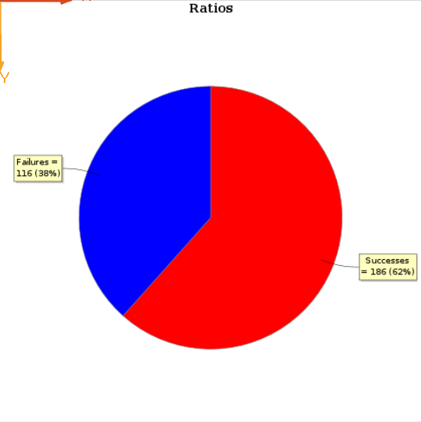
Experiment 1. Control
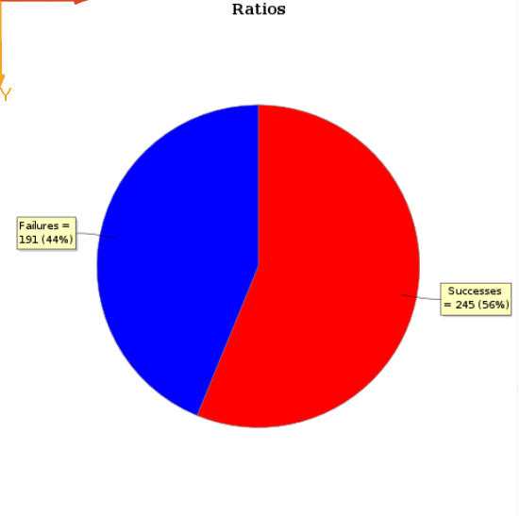
Experiment 2. Number of Vendors Doubled
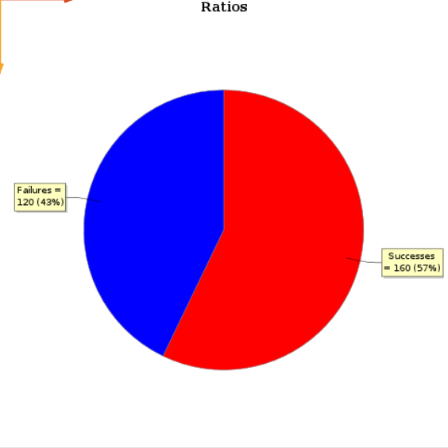
Experiment 3. Number of Performers Doubled
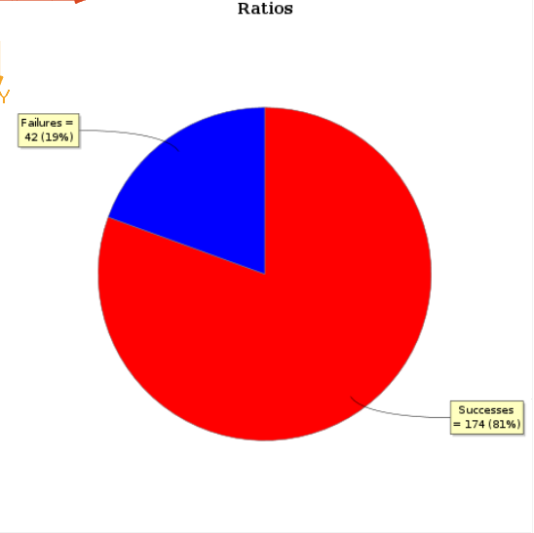
Experiment 4. Number of Attendees Doubled

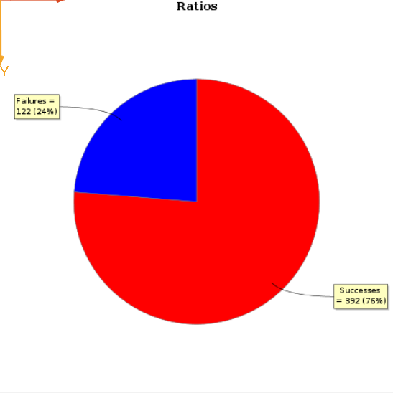
Experiment 5. Number of Thieves Doubled
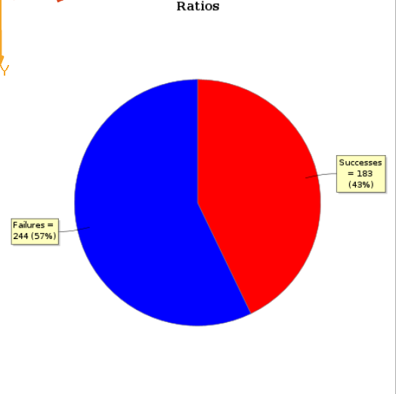
Experiment 6. Number of Guards Doubled

Conclusion
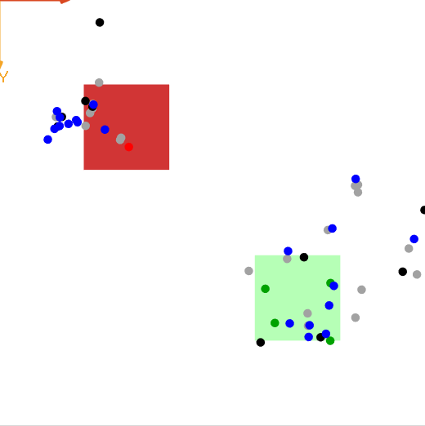
Figure 1. Snapshot of a Run
Unsurprisingly most effective way of dealing with thieves was to increase the number of guards. Naturally, increasing the number of thieves or victims led to more thievery. Other factors were not as important since vendors and performers were concentrated on a designated area.
Overall, the most challenging part of the assignment was to come up with a creative idea. However, it was a fun experience overall.

